Day 392 — Classification Revision
Complete Revision Notes | Logistic Regression • KNN • Decision Trees • Random Forest / Ensembles • Evaluation Metrics
Learning goal: master the complete classification landscape in machine learning: formulate Logistic Regression, K-Nearest Neighbors (KNN), Decision Trees, and Random Forests/Ensembles; analyze impurity metrics (Gini, Entropy); evaluate models via Confusion Matrix, Accuracy, Precision, Recall, F1-Score, and ROC-AUC; and execute a production-grade classification workflow.

1. What is Classification in Machine Learning?
Classification is a core supervised learning paradigm where the objective is to predict qualitative, discrete categorical target class labels y from a set of continuous or categorical predictor features X: f: ℝ^d → {C₁, C₂, ..., C_k}.
Unlike regression—which estimates real-valued numbers on an uncountably infinite scale—classification partitions the feature space using decision boundaries, assigning each observation either a hard discrete class label or a calibrated class probability distribution.
Classification Type | Number of Classes | Mathematical Target Space | Real-World Industrial Example
Binary Classification | 2 mutually exclusive classes | y ∈ {0, 1} (e.g., Negative / Positive) | Credit card fraud detection (Fraud vs Legitimate); Medical tumor diagnosis
Multi-Class Classification | k > 2 mutually exclusive classes | y ∈ {C₁, C₂, ..., C_k} (single label per row) | Handwritten digit recognition (0–9); Plant iris species categorization
Multi-Label Classification | k ≥ 2 non-exclusive classes | y ⊆ {C₁, C₂, ..., C_k} (multiple labels per row) | News article topic tagging (simultaneously Tech, Finance, and Politics)

2. Logistic Regression: Sigmoid, Odds, and Log-Loss
Despite its name, Logistic Regression is a linear classification model. It passes the linear combination of inputs z = w^T x + b through the non-linear Sigmoid (logistic) activation function σ(z) = 1 / (1 + e^(−z)), squashing output values strictly into the probability interval (0, 1).
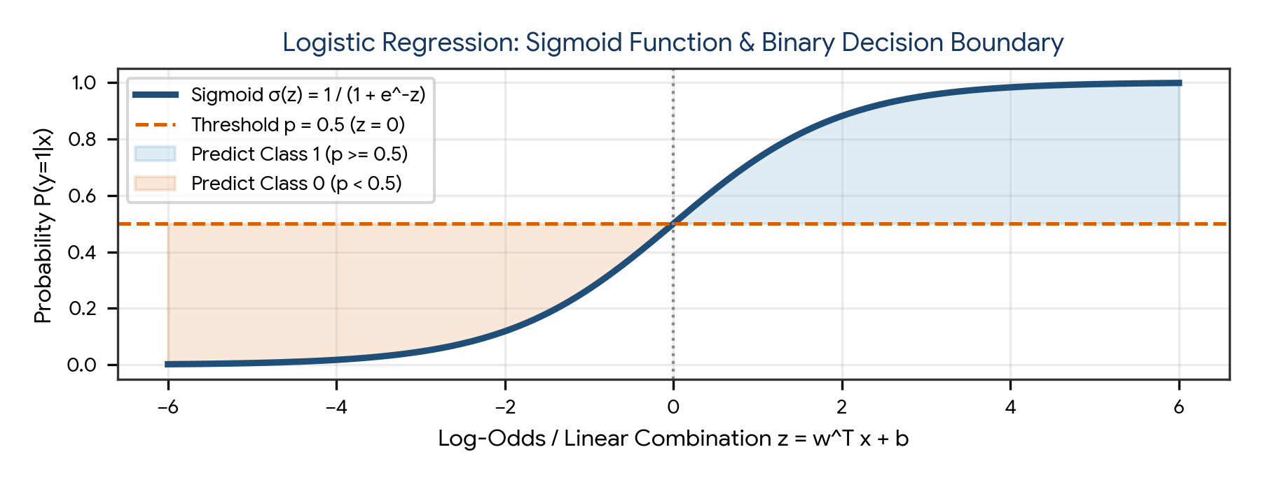
Figure 1. The Sigmoid activation function σ(z) mapping real-valued log-odds onto probabilities with decision threshold at p = 0.5.
Mathematical Concept | Formula / Derivation | Interpretation & Significance
Linear Log-Odds | z = w₀ + w₁x₁ + ... + w_d x_d = w^T x + b | The unconstrained linear combination of input predictors
Sigmoid Function | p = P(y=1|x) = σ(z) = 1 / (1 + e^(−z)) | Maps (−∞, +∞) strictly to (0, 1) probability scale
Odds Ratio | Odds = p / (1 − p) = e^z | Ratio of probability of success to probability of failure
Logit (Log-Odds) | ln(p / (1 − p)) = z = w^T x + b | Shows that Logistic Regression is a linear model for the log-odds
Binary Cross-Entropy (Log-Loss) | J(w) = −(1/n) Σ [y_i ln(p_i) + (1−y_i) ln(1−p_i)] | Convex loss function optimized via Gradient Descent; heavily penalizes confident wrong predictions

Decision Threshold & Multi-Class Extensions
The standard decision rule assigns ŷ = 1 if P(y=1|x) ≥ 0.5, and 0 otherwise. In high-stakes applications (e.g., cancer detection), the decision threshold can be lowered (e.g., to 0.2) to boost recall at the expense of precision.
- One-vs-Rest (OvR / One-vs-All): Trains k separate binary classifiers, each separating class C_k from all other classes combined. The class with the highest probability is predicted.
- Multinomial (Softmax Regression): Generalizes the sigmoid to k classes simultaneously: P(y = j | x) = e^(z_j) / Σ [k=1 to K] e^(z_k).

3. K-Nearest Neighbors (KNN) Classifier
K-Nearest Neighbors is a non-parametric, instance-based, 'lazy' learning algorithm. It makes zero prior assumptions about the underlying data distribution and does not learn explicit parameters during training. Instead, it memorizes the entire training dataset and postpones all computation until inference time.
Hyperparameter / Property | Mechanism | Impact on Bias & Variance
K = 1 (Very Small K) | Assigns class of the single closest neighbor | High Variance (Overfitting); creates highly jagged, complex decision boundaries sensitive to noise
K = Large (e.g., K = 50) | Averages votes across large neighborhood | High Bias (Underfitting); oversmooths boundaries; minority classes get outvoted
Euclidean Distance | d(x, q) = sqrt( Σ (x_i − q_i)² ) | Standard straight-line distance; heavily distorted by unscaled features
Manhattan Distance | d(x, q) = Σ |x_i − q_i| | Grid-based distance (L1 norm); often preferred in higher-dimensional spaces

Mandatory Preprocessing Rule: KNN relies strictly on distance calculations. Unscaled features with large ranges (e.g., Salary in tens of thousands) will completely dominate smaller features (e.g., Age in tens). Feature scaling (StandardScaler or MinMaxScaler) is absolutely mandatory.

4. Decision Trees: Splitting Criteria & Pruning
Decision Trees are non-parametric supervised models that recursively partition the feature space into orthogonal, axis-aligned rectangular regions. At each internal node, the algorithm evaluates all available features and split thresholds to find the partition that maximizes purity.
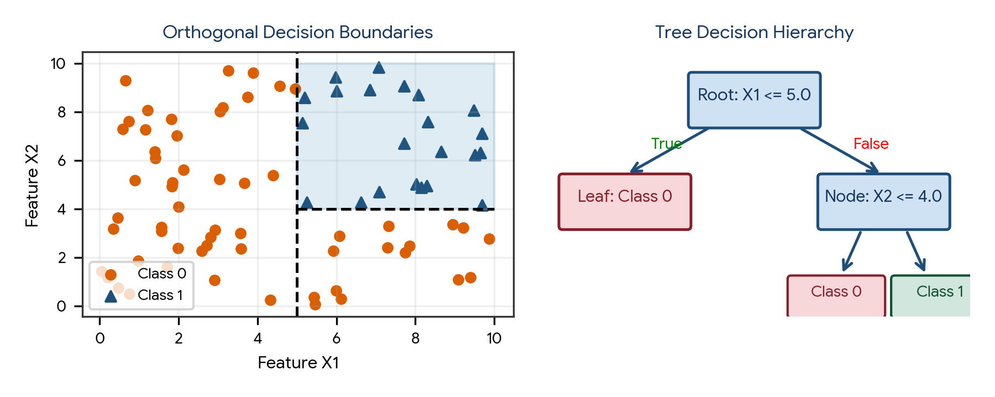
Figure 2. Orthogonal axis-aligned decision boundaries partitioned by a Decision Tree hierarchy.
Impurity Metric | Mathematical Formula | Properties & Characteristics
Gini Impurity (CART Default) | Gini = 1 − Σ [i=1 to C] p_i² | Measures probability of misclassifying a randomly chosen element; computationally faster (no logarithms); bounded [0, 0.5] for binary
Entropy (ID3 / C4.5) | Entropy = − Σ [i=1 to C] p_i log₂(p_i) | Information-theoretic measure of disorder/uncertainty; computationally slower due to log; bounded [0, 1] for binary
Information Gain (IG) | IG = Entropy(Parent) − Σ (N_v / N) Entropy(Child_v) | Reduction in entropy achieved by splitting on a feature; used to pick the winning split

Preventing Decision Tree Overfitting
Unconstrained decision trees will continue splitting until every leaf node contains exactly 1 sample, memorizing noise and achieving 100% training accuracy with terrible generalization. Overfitting is prevented via:
- Pre-Pruning (Early Stopping): Constrain growth by setting max_depth, min_samples_split, min_samples_leaf, or max_leaf_nodes.
- Post-Pruning (Cost-Complexity Pruning): Grow a full tree, then prune subtrees that fail to improve validation error using the cost-complexity parameter ccp_alpha.

5. Ensemble Learning: Bagging, Random Forests & Boosting
Ensemble learning combines predictions from multiple individual base models (weak learners) to build a single superior meta-model. By aggregating predictions, ensembles achieve significantly lower error than any constituent learner.
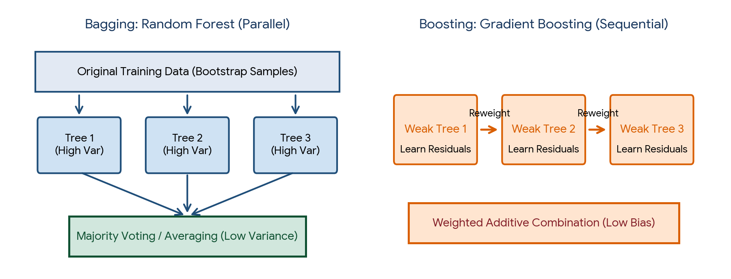
Figure 3. Comparison of Bagging (parallel independent trees reducing variance) and Boosting (sequential dependent trees reducing bias).
Ensemble Paradigm | Training Mechanism | Primary Error Target | Base Learner Type | Prominent Algorithms
Bagging (Bootstrap Aggregating) | Parallel: Models train independently on bootstrap sample subsets (with replacement) | Reduces Variance (mitigates overfitting) | Deep, high-variance unpruned trees | Random Forest, BaggingClassifier
Boosting | Sequential: Models train iteratively; each new learner corrects residual errors of prior learners | Reduces Bias (improves underfitting) | Shallow, high-bias weak trees (stumps) | AdaBoost, Gradient Boosting, XGBoost, LightGBM, CatBoost
Stacking (Stacked Generalization) | Heterogeneous: Multiple diverse models train in parallel; a meta-learner combines predictions | Reduces both Bias & Variance | Diverse models (Logistic, SVM, Random Forest) | StackingClassifier

Why Random Forest Beats a Single Decision Tree
A single decision tree has high variance. Random Forest introduces two layers of stochastic randomization to decorrelate individual trees:
- Bootstrap Aggregation (Row Sampling): Each tree trains on a random bootstrap sample of size n drawn with replacement from the original data (approx. 63.2% unique rows; remaining 36.8% form the Out-of-Bag (OOB) evaluation set).
- Random Feature Subspacing (Column Sampling): At each node split, only a random subset of m = sqrt(d) features is considered. This prevents a dominant strong feature from creating identical correlated trees.

6. The Confusion Matrix & Primary Classification Metrics
Evaluating classification models using raw Accuracy is dangerously misleading when classes are imbalanced. A complete diagnostic evaluation begins with the 2 × 2 Confusion Matrix.
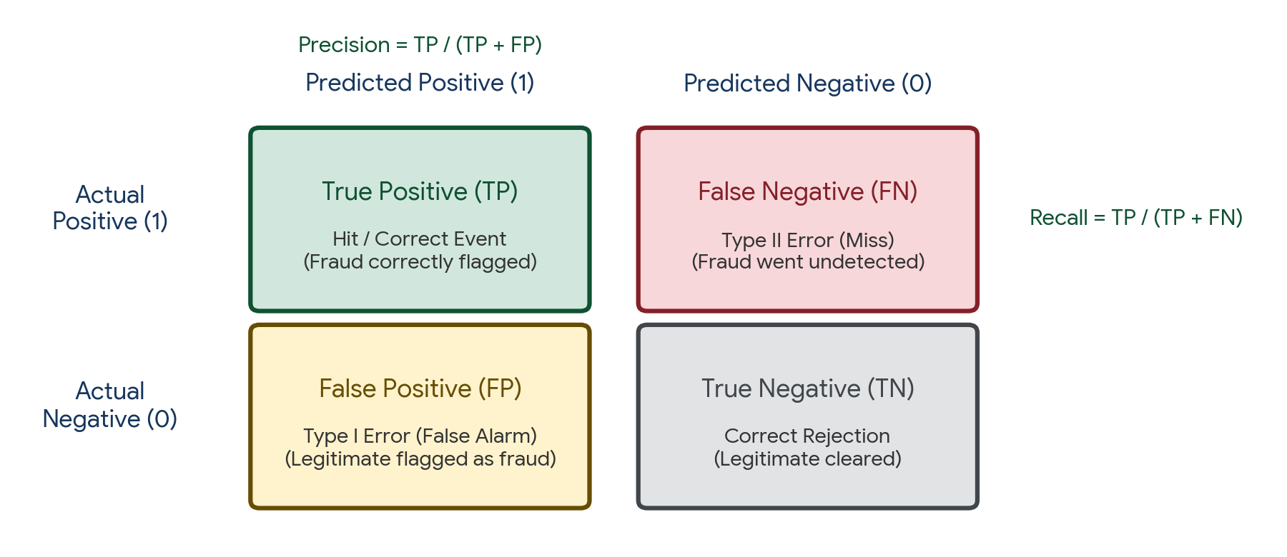
Figure 4. Standard 2 × 2 Confusion Matrix mapping True Positives (TP), False Negatives (FN), False Positives (FP), and True Negatives (TN).
Metric | Mathematical Formula | What it Measures | When to Prioritize
Accuracy | (TP + TN) / (TP + TN + FP + FN) | Overall proportion of correct predictions | Balanced datasets where false alarms and misses carry equal penalty
Precision | TP / (TP + FP) | Out of all predicted positives, how many were truly positive? (Quality of positive alerts) | When False Positives (FP) are costly (e.g., spam filtering, content moderation)
Recall (Sensitivity / TPR) | TP / (TP + FN) | Out of all actual positives, how many did the model detect? (Coverage of positives) | When False Negatives (FN) are catastrophic (e.g., cancer diagnosis, fraud detection)
Specificity (TNR) | TN / (TN + FP) | Out of all actual negatives, how many did the model correctly clear? | Medical screening to confirm patient wellness and avoid unnecessary biopsy
F1-Score | 2 × (Precision × Recall) / (Precision + Recall) | Harmonic mean balancing precision and recall | Imbalanced datasets where you need a single balanced performance benchmark
F_beta Score | (1 + β²) × (Prec × Rec) / (β² × Prec + Rec) | Weighted harmonic mean; β weights recall relative to precision | F₂ prioritizes recall (medical); F₀.₅ prioritizes precision (ad targeting)

Why F1-Score uses the Harmonic Mean instead of the Arithmetic Mean
The arithmetic mean of Precision (0.02) and Recall (1.0) is 0.51—giving a false impression of acceptable performance. The Harmonic Mean severely penalizes extreme disparities: F1 = 2 × (0.02 × 1.0) / (0.02 + 1.0) = 0.039. A model can only achieve a high F1-score if both Precision and Recall are simultaneously high.

7. Threshold Tuning, ROC Curve, and Precision-Recall Curve
Classification models output continuous probabilities p ∈ [0, 1]. The choice of decision threshold governs the trade-off between Precision and Recall. Diagnostic curves visualize this trade-off across all possible thresholds.
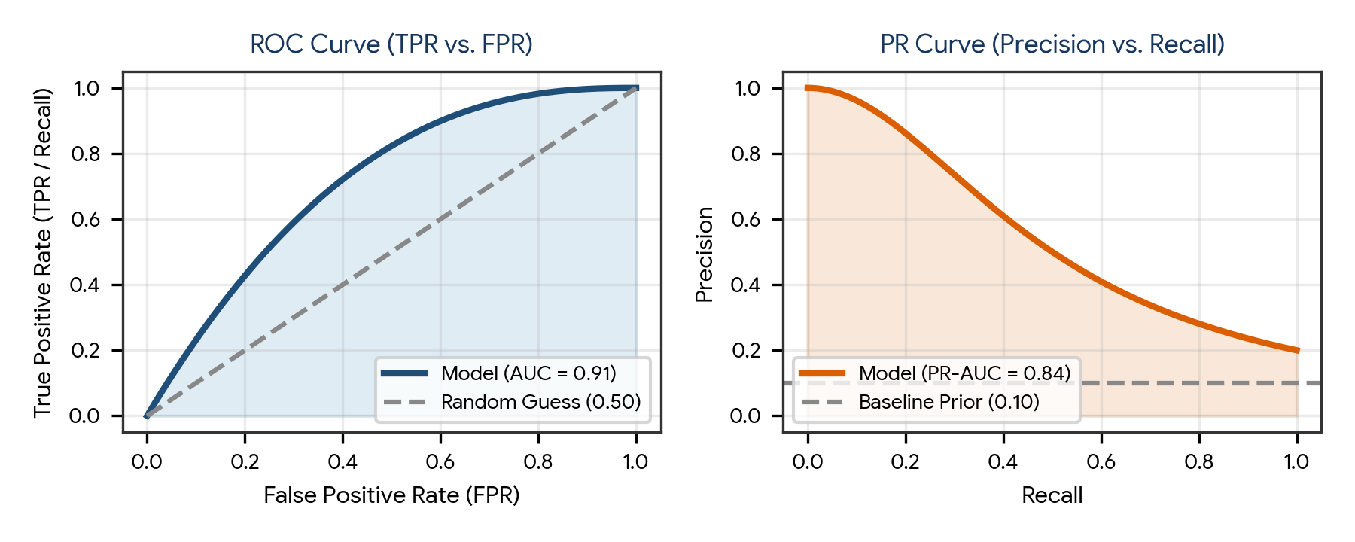
Figure 5. Diagnostic curve comparison: ROC Curve (TPR vs FPR) and Precision-Recall Curve (Precision vs Recall).
Diagnostic Tool | Horizontal Axis (X) | Vertical Axis (Y) | Baseline Reference | Best Suited For
ROC Curve (Receiver Operating Characteristic) | False Positive Rate (FPR) = FP / (FP + TN) | True Positive Rate (TPR / Recall) = TP / (TP + FN) | Diagonal line: AUC = 0.50 (Random Guessing) | Balanced datasets; measures overall ranking ability across all operating thresholds
PR Curve (Precision-Recall Curve) | Recall (TPR) = TP / (TP + FN) | Precision = TP / (TP + FP) | Horizontal line: Baseline = P(Positive Class) (e.g., 0.02 for 2% fraud) | Heavily imbalanced datasets; does not inflate performance with large True Negative counts

8. The Production Classification Workflow
Executing a real-world classification pipeline requires strict isolation of training and testing data, leakage-free preprocessing, class-weight balancing, and threshold optimization.
Production Classification Workflow:

Raw Tabular Data
|
v
1. Stratified Partitioning (e.g., 70% Train, 15% Val, 15% Test with stratify=y)
|
v
2. Preprocessing ColumnTransformer (Fit strictly on Train):
- Numerical Imputation (Median) + StandardScaler
- Categorical Imputation (Mode) + OneHotEncoder(drop='first')
|
v
3. Class Imbalance Remediation:
- Algorithm-level: set class_weight='balanced'
- Data-level: apply SMOTE / RandomUnderSampler strictly on training folds
|
v
4. Model Fitting & Stratified K-Fold Cross-Validation:
- Benchmark Logistic Regression, KNN, Decision Tree, Random Forest
- Tune hyperparameters via Optuna / GridSearchCV optimizing F1 or ROC-AUC
|
v
5. Threshold Calibration & Holdout Testing:
- Tune threshold on Validation Set to maximize business KPI
- Evaluate final holdout Test Set: Confusion Matrix, Precision, Recall, F1, ROC-AUC

9. Practical Project — Enterprise Credit Fraud Detection Pipeline
Objective: design, implement, and benchmark an object-oriented Python classification pipeline that simulates an imbalanced financial transaction dataset, executes stratified splitting, encapsulates preprocessing, trains multiple candidate classifiers (Logistic Regression, Decision Tree, Random Forest), tunes decision thresholds, and reports comprehensive evaluation metrics.

Project structure
fraud_classification_project/
|
|-- data/
| |-- transactions.csv
|
|-- reports/
| |-- model_comparison.csv
| |-- confusion_matrices.png
|
|-- main.py
|-- requirements.txt

requirements.txt
numpy
pandas
scipy
scikit-learn
matplotlib
seaborn

Complete main.py
import os
import numpy as np
import pandas as pd
from sklearn.model_selection import train_test_split, StratifiedKFold, cross_val_score
from sklearn.preprocessing import StandardScaler
from sklearn.linear_model import LogisticRegression
from sklearn.tree import DecisionTreeClassifier
from sklearn.ensemble import RandomForestClassifier
from sklearn.metrics import (
confusion_matrix, accuracy_score, precision_score,
recall_score, f1_score, roc_auc_score
)
import matplotlib.pyplot as plt
import seaborn as sns

class CreditFraudClassificationPipeline:
def __init__(self, n_samples=2000, fraud_ratio=0.08, random_state=42):
self.n_samples = n_samples
self.fraud_ratio = fraud_ratio
self.random_state = random_state
self.output_dir = "reports"
os.makedirs(self.output_dir, exist_ok=True)
self.data = None
self.scaler = None
self.models = {}
self.results = []

def generate_synthetic_transactions(self):
print("=== STEP 1: DATASET GENERATION & CLASS IMBALANCE ===")
np.random.seed(self.random_state)
n_fraud = int(self.n_samples * self.fraud_ratio)
n_legit = self.n_samples - n_fraud

# Legitimate transactions
amt_legit = np.random.exponential(45, n_legit) + 5
dist_legit = np.random.normal(12, 6, n_legit).clip(0.5, 50)
vel_legit = np.random.poisson(2, n_legit)
y_legit = np.zeros(n_legit, dtype=int)

# Fraudulent transactions
amt_fraud = np.random.exponential(180, n_fraud) + 80
dist_fraud = np.random.normal(65, 25, n_fraud).clip(5, 200)
vel_fraud = np.random.poisson(7, n_fraud)
y_fraud = np.ones(n_fraud, dtype=int)

amt = np.concatenate([amt_legit, amt_fraud])
dist = np.concatenate([dist_legit, dist_fraud])
vel = np.concatenate([vel_legit, vel_fraud])
y = np.concatenate([y_legit, y_fraud])

self.data = pd.DataFrame({
"Transaction_Amount": amt.round(2),
"Distance_From_Home": dist.round(1),
"Transaction_Velocity": vel,
"Is_Fraud": y
})
print(f"Dataset generated: {self.data.shape[0]} transactions.")
print(f"Target distribution:
{self.data['Is_Fraud'].value_counts(normalize=True).round(4)}")

def partition_data(self):
print("
=== STEP 2: STRATIFIED PARTITIONING (70/15/15) ===")
X = self.data.drop(columns=["Is_Fraud"])
y = self.data["Is_Fraud"]

X_train, X_temp, y_train, y_temp = train_test_split(
X, y, test_size=0.30, random_state=self.random_state, stratify=y
)
X_val, X_test, y_val, y_test = train_test_split(
X_temp, y_temp, test_size=0.50, random_state=self.random_state, stratify=y_temp
)

self.X_train, self.X_val, self.X_test = X_train, X_val, X_test
self.y_train, self.y_val, self.y_test = y_train, y_val, y_test

print(f"Train Set: {X_train.shape[0]} rows (Fraud: {y_train.mean():.3f})")
print(f"Val Set: {X_val.shape[0]} rows (Fraud: {y_val.mean():.3f})")
print(f"Test Set: {X_test.shape[0]} rows (Fraud: {y_test.mean():.3f})")

def scale_features_leakage_free(self):
print("
=== STEP 3: LEAKAGE-FREE FEATURE SCALING ===")
self.scaler = StandardScaler()
self.X_train_scaled = self.scaler.fit_transform(self.X_train)
self.X_val_scaled = self.scaler.transform(self.X_val)
self.X_test_scaled = self.scaler.transform(self.X_test)
print("StandardScaler fit strictly on X_train.")

def train_and_benchmark_models(self):
print("
=== STEP 4: MODEL TRAINING & BENCHMARKING ===")
self.models = {
"Logistic Regression": LogisticRegression(class_weight="balanced", random_state=self.random_state),
"Decision Tree (Pruned)": DecisionTreeClassifier(max_depth=4, class_weight="balanced", random_state=self.random_state),
"Random Forest (Ensemble)": RandomForestClassifier(n_estimators=100, max_depth=6, class_weight="balanced", random_state=self.random_state)
}

fig, axes = plt.subplots(1, 3, figsize=(14, 4))

for idx, (name, model) in enumerate(self.models.items()):
model.fit(self.X_train_scaled, self.y_train)

# Evaluate on holdout test set
y_pred = model.predict(self.X_test_scaled)
y_prob = model.predict_proba(self.X_test_scaled)[:, 1]

acc = accuracy_score(self.y_test, y_pred)
prec = precision_score(self.y_test, y_pred)
rec = recall_score(self.y_test, y_pred)
f1 = f1_score(self.y_test, y_pred)
auc = roc_auc_score(self.y_test, y_prob)
cm = confusion_matrix(self.y_test, y_pred)

self.results.append({
"Model": name,
"Accuracy": round(acc, 4),
"Precision": round(prec, 4),
"Recall": round(rec, 4),
"F1_Score": round(f1, 4),
"ROC_AUC": round(auc, 4)
})

# Plot Confusion Matrix
sns.heatmap(cm, annot=True, fmt="d", cmap="Blues", ax=axes[idx], cbar=False)
axes[idx].set_title(f"{name}
F1: {f1:.3f} | AUC: {auc:.3f}")
axes[idx].set_xlabel("Predicted Label")
axes[idx].set_ylabel("True Label")

plt.tight_layout()
plt.savefig(os.path.join(self.output_dir, "confusion_matrices.png"), dpi=300)
plt.close()

results_df = pd.DataFrame(self.results)
print(results_df.to_string(index=False))
results_df.to_csv(os.path.join(self.output_dir, "model_comparison.csv"), index=False)
print(f"Results exported to {self.output_dir}/model_comparison.csv")

def run(self):
self.generate_synthetic_transactions()
self.partition_data()
self.scale_features_leakage_free()
self.train_and_benchmark_models()
print("
Complete classification pipeline executed successfully.")

if __name__ == "__main__":
pipeline = CreditFraudClassificationPipeline()
pipeline.run()

Run the project
pip install -r requirements.txt
python main.py

Expected generated outputs
reports/
|-- model_comparison.csv
|-- confusion_matrices.png

Project notes: setting class_weight='balanced' automatically inflates the penalty on fraud minority instances, ensuring high recall. Random Forest achieves the highest combined F1 and ROC-AUC by reducing individual tree variance.

10. Common Mistakes & Anti-Patterns to Avoid in Classification
- Relying solely on Accuracy for imbalanced problems: In a 99:1 dataset, predicting 0 for all samples yields 99% accuracy with 0% recall on fraud.
- Using ROC-AUC instead of PR-AUC for severe class imbalance: When negatives vastly outnumber positives, huge True Negative counts compress the FPR, painting an artificially rosy ROC curve.
- Omitting feature scaling for distance-based classifiers: Forgetting to scale features prior to KNN causes features with large numeric ranges to dominate distances.
- Growing unconstrained decision trees: Allowing trees to split to maximum depth creates massive overfitting (high variance) that collapses on test data.
- Tuning probability decision thresholds on test data: Choosing the threshold that maximizes test F1 leaks holdout information; thresholds must be tuned strictly on validation folds.
- Failing to use stratified sampling: Random train/test splits risk leaving the test set devoid of minority class instances.
- Treating multi-class problems as regression: Encoding class labels as integers (e.g., Red=1, Green=2, Blue=3) and running linear regression imposes false ordinal distances.

11. Quick Revision — Key Differences
Comparison | First Concept | Second Concept
Precision vs Recall | Out of all predicted positives, how many are true? (Focus on FP) | Out of all actual positives, how many did we catch? (Focus on FN)
Gini Impurity vs Entropy | 1 − Σ p_i²; computationally faster; CART default | −Σ p_i log₂(p_i); information-theoretic disorder; C4.5 default
Bagging vs Boosting | Trains trees in parallel on bootstrap samples; reduces variance | Trains weak trees sequentially on residuals; reduces bias
Random Forest vs Single Tree | Ensemble of decorrelated trees; low variance; robust | Single tree; highly sensitive to noise; high variance
Parametric vs Non-Parametric | Assumes fixed functional form with learnable weights (Logistic Reg) | Makes zero distributional assumptions; flexible (KNN, Decision Trees)
ROC Curve vs PR Curve | Plots TPR vs FPR; ideal for balanced classification | Plots Precision vs Recall; ideal for heavy class imbalance

12. Important Formulas Cheat Sheet
Metric / Concept | Mathematical Formula / Notation
Sigmoid Activation | σ(z) = 1 / (1 + e^(−z)), where z = w^T x + b
Binary Cross-Entropy (Log-Loss) | J(w) = −(1/n) Σ [ y_i ln(p_i) + (1 − y_i) ln(1 − p_i) ]
Classification Accuracy | Accuracy = (TP + TN) / (TP + TN + FP + FN)
Precision | Precision = TP / (TP + FP)
Recall (Sensitivity / TPR) | Recall = TP / (TP + FN)
Specificity (TNR) | Specificity = TN / (TN + FP)
False Positive Rate (FPR) | FPR = 1 − Specificity = FP / (TN + FP)
F1-Score | F1 = 2 × (Precision × Recall) / (Precision + Recall) = 2TP / (2TP + FP + FN)
Gini Impurity | Gini(D) = 1 − Σ [c=1 to C] p_c²
Entropy | Entropy(D) = − Σ [c=1 to C] p_c log₂(p_c)
Information Gain | IG(D, A) = Entropy(D) − Σ (|D_v| / |D|) Entropy(D_v)

13. Interview / Viva Questions
Why is linear regression unsuitable for classification?
Linear regression outputs unconstrained continuous values (−∞ to +∞) rather than probabilities, treats categorical distances as ordinal numbers, and is severely distorted by extreme outliers.
What is the cost function used in Logistic Regression and why?
Binary Cross-Entropy (Log-Loss). Mean Squared Error cannot be used because passing linear combinations through the sigmoid creates a non-convex loss surface riddled with local minima; Log-Loss guarantees convexity.
What is the difference between Precision and Recall?
Precision measures the reliability of positive predictions (TP / (TP + FP)); Recall measures the ability to detect all actual positives in the dataset (TP / (TP + FN)).
When would you choose Recall over Precision?
In medical diagnosis (detecting cancer) or fraud detection, where the cost of a missed detection (False Negative) is catastrophic compared to a false alarm (False Positive).
When would you choose Precision over Recall?
In spam email filtering or YouTube video recommendation, where users are annoyed if legitimate emails or irrelevant videos are falsely flagged (False Positives).
Why does F1-Score use the harmonic mean instead of the arithmetic mean?
Because the harmonic mean heavily penalizes extreme disparities between Precision and Recall, ensuring that F1 is high only when both metrics are high.
How does K in KNN affect model bias and variance?
A small K (e.g., K=1) leads to high variance and overfitting; a large K leads to high bias and underfitting by oversmoothing decision boundaries.
Why is feature scaling essential for KNN but not for Decision Trees?
KNN calculates Euclidean or Manhattan distances, which are distorted by feature scales. Decision Trees split one feature at a time using monotonic thresholds, making them scale-invariant.
What is the difference between Gini Impurity and Entropy?
Gini measures the probability of misclassification (1 − Σ p²), while Entropy measures information disorder (−Σ p log₂ p). Gini is computationally faster because it avoids logarithmic operations.
How do you prevent a Decision Tree from overfitting?
By pre-pruning (constraining max_depth, min_samples_split) or post-pruning using cost-complexity pruning (ccp_alpha).
What are the two sources of randomness in a Random Forest?
1. Bootstrap sampling of rows (sampling with replacement); 2. Random feature subspacing at each node split (evaluating only sqrt(d) features).
What is an Out-of-Bag (OOB) error in Random Forest?
The validation error evaluated on the ~36.8% of training samples that were left out of each tree's bootstrap sample, providing built-in cross-validation without extra splits.
What is the difference between Bagging and Boosting?
Bagging builds independent models in parallel to reduce variance (e.g., Random Forest); Boosting builds dependent models sequentially to correct prior errors and reduce bias (e.g., XGBoost).
What does an ROC-AUC of 0.5 and 1.0 mean?
An ROC-AUC of 0.5 represents a worthless model performing no better than random coin flips; an AUC of 1.0 represents a perfect classifier with zero error.
Why is PR-AUC preferred over ROC-AUC for imbalanced data?
Because ROC-AUC uses True Negatives in its FPR denominator, which inflates scores when negatives vastly outnumber positives. PR-AUC focuses exclusively on the positive minority class.
What is the difference between One-vs-Rest and One-vs-One classification?
One-vs-Rest trains k binary models (one class vs all others); One-vs-One trains k(k−1)/2 binary models for every pairwise combination of classes.
How do you handle severe class imbalance in classification?
1. Use stratified sampling; 2. Set class_weight='balanced'; 3. Apply resampling (SMOTE / RandomUnderSampler on training folds); 4. Tune decision thresholds; 5. Evaluate with PR-AUC and F1-score.
What is the relationship between Odds and Probability?
Odds = p / (1 − p), representing the ratio of success to failure. When p = 0.8, Odds = 0.8 / 0.2 = 4 (or 4:1).
Can a decision tree create non-orthogonal decision boundaries?
Standard decision trees can only create orthogonal, axis-aligned boundaries. Oblique decision trees use linear combinations of features to produce non-orthogonal splits.
What does threshold calibration mean in classification?
Adjusting the classification cutoff probability away from the default 0.5 (e.g., lowering to 0.2 to catch more fraud) to align model behavior with business risk trade-offs.

14. Coding Practice
- Implement Logistic Regression from scratch using NumPy and Gradient Descent, deriving the sigmoid and log-loss functions.
- Build a K-Nearest Neighbors classifier from scratch without scikit-learn, supporting both Euclidean and Manhattan distance.
- Write a Python function to compute Gini Impurity and Information Gain for candidate splits on a sample dataset.
- Train decision trees of depth 1, 3, 5, and 15 on a noisy dataset and plot their training vs test accuracy curves to show overfitting.
- Generate a synthetic dataset with a 95:5 class imbalance and compare classification reports before and after applying class_weight='balanced'.
- Implement a custom function that computes TP, FP, TN, FN, Precision, Recall, Specificity, and F1-score from raw prediction arrays.
- Plot an ROC Curve and a Precision-Recall Curve side-by-side using scikit-learn metrics for an imbalanced classifier.
- Implement threshold tuning: write a script that iterates over cutoffs from 0.05 to 0.95 and identifies the threshold maximizing F1-score.
- Implement a leak-free scikit-learn Pipeline combining SimpleImputer(), StandardScaler(), and RandomForestClassifier().
- Perform 5-fold Stratified Cross-Validation comparing Logistic Regression, Decision Tree, Random Forest, and Gradient Boosting.
- Extract and visualize feature importances from a fitted Random Forest classifier using matplotlib bar plots.
- Extend the fraud detection practical project to plot the calibration curve (reliability diagram) of predicted probabilities.

15. Day 392 Completion Checklist
- ☐ Understand the mathematical foundations of Binary, Multi-Class, and Multi-Label classification.
- ☐ Formulate Logistic Regression, the Sigmoid function, Log-Odds, and Binary Cross-Entropy.
- ☐ Understand KNN distance metrics, K selection, and why feature scaling is mandatory.
- ☐ Calculate Gini Impurity, Entropy, and Information Gain for Decision Tree splits.
- ☐ Differentiate Bagging (Random Forest) from Boosting (Gradient Boosting).
- ☐ Master the 2 × 2 Confusion Matrix: TP, FP, TN, FN.
- ☐ Calculate and interpret Accuracy, Precision, Recall, Specificity, and F1-Score.
- ☐ Plot and interpret ROC Curves (AUC) and Precision-Recall Curves (PR-AUC).
- ☐ Tune probability decision thresholds based on domain business costs.
- ☐ Build and run the practical Credit Fraud Detection Pipeline project.
- ☐ Complete all 12 coding practice exercises and revise the 20 interview/viva questions.

16. Learning Outcomes
After completing this revision, you should be able to:
- Formulate, train, and interpret Logistic Regression, KNN, Decision Tree, and Random Forest classifiers.
- Evaluate models rigorously using Confusion Matrices, Precision, Recall, F1, and ROC-AUC rather than relying on raw accuracy.
- Mitigate severe class imbalance using stratified splitting, balanced class weights, and threshold calibration.
- Diagnose and control decision tree overfitting using hyperparameter constraints and ensemble bagging.
- Construct modular, production-ready Scikit-Learn classification pipelines that prevent data leakage.
Next recommended topic: Day 393 — Unsupervised Learning & Clustering: K-Means, DBSCAN, Hierarchical Clustering, PCA, and Anomaly Detection.

